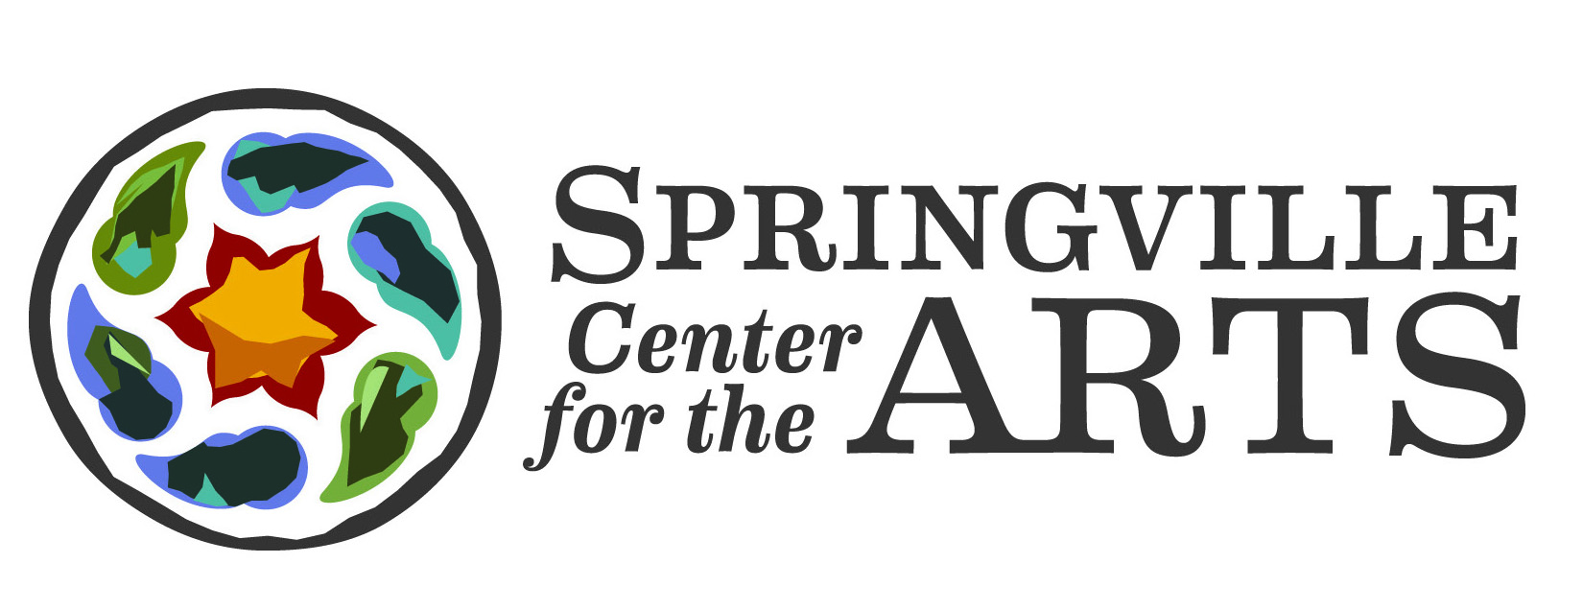
Summer Internship / Residency
Application

Name: ______________________________________________________________________
Home Address: ______________________________________________________________
Home City: __________________________________________________________________
Home State: __________ Zip Code: ______________________
Phone Number: _________________________ Date of Birth: ___________________
E-mail: _____________________________________________________________________
School: ____________________________________________________________________
City: _______________________________________________________________________
State: _________________________ Major(s): ____________________________________
Are you currently enrolled as a student? ☐ Yes ☐ No
Fall level of study: ☐ Freshman ☐ Sophomore ☐ Junior ☐ Senior ☐ Graduate Level
Will you receive academic credit for this internship? ☐ Yes ☐ No
How did you hear about this internship? ________________________________________
Please include the following with your application:
- Personal statement of 500 words or less of why this internship is a good match for you
- Two letters of recommendation
- Resume of your related experience
- Optional: Work Samples

Please e-mail application materials to:
Tracy Maybray, Director of Operations – scatracym@gmail.com
Springville Center for the Arts - P.O. Box 62 - Springville, NY 14141

Children’s Visual Arts
Summer Internship / Residency

Springville Center for the Arts (SCA) has an extensive history of offering summer art programs to the youth of our community. We routinely hire four Theater Arts interns to facilitate drama workshops. This year we are expanding the program to include a six week Visual Arts internship / residency open to college students.

Participants will:
- Teach/direct a variety of workshops including Drawing, Painting, Puppetry, Public Art, and more. Class topics are based on the skill set of the applicants.
- Assist our existing SPARK (Creative programs based on the Reggio Emilia approach) instructors with SPARK sessions.
- Assist our Theater interns and students with set design for their musical productions (Two Elementary and Middle School productions, 1 High School/College production).
The program begins July 7 and ends August 18 (6 weeks).
Springville Center for the Arts is a growing multi-arts center located in a rural community in Western New York State. An apartment shared with other interns and a stipend of $150 per week is provided.

Requirements
- Because of legal requirements, you must be seeking a degree in an arts or education related field: Art, Arts Education, Graphic Art, Art History, Painting/Drawing, Sculpture, etc.
- Comfort working with, teaching, and/or leading children in a workshop setting.
- Self-initiative. Participants work with staff to create and facilitate programs.
- You must be comfortable with a broad variety of programs.
- All staff are representatives of SCA and must support the overall mission of the organization: Ignited by the arts, Springville is known far and wide as a vibrant, creative community where people want to live, work and play.
- You must be able to expand upon workshop concepts and execute all aspects of those programs. Including developing supply needs, acquiring supplies, communicate with the students and parents, setting up and cleaning up the class spaces.

Applications will be accepted until the position is filled. Decisions will typically be made by the end of April.
SpringvilleArts.org - 716-592-9038 - scatracym@gmail.com

